User Story Maps – for Checkout Process
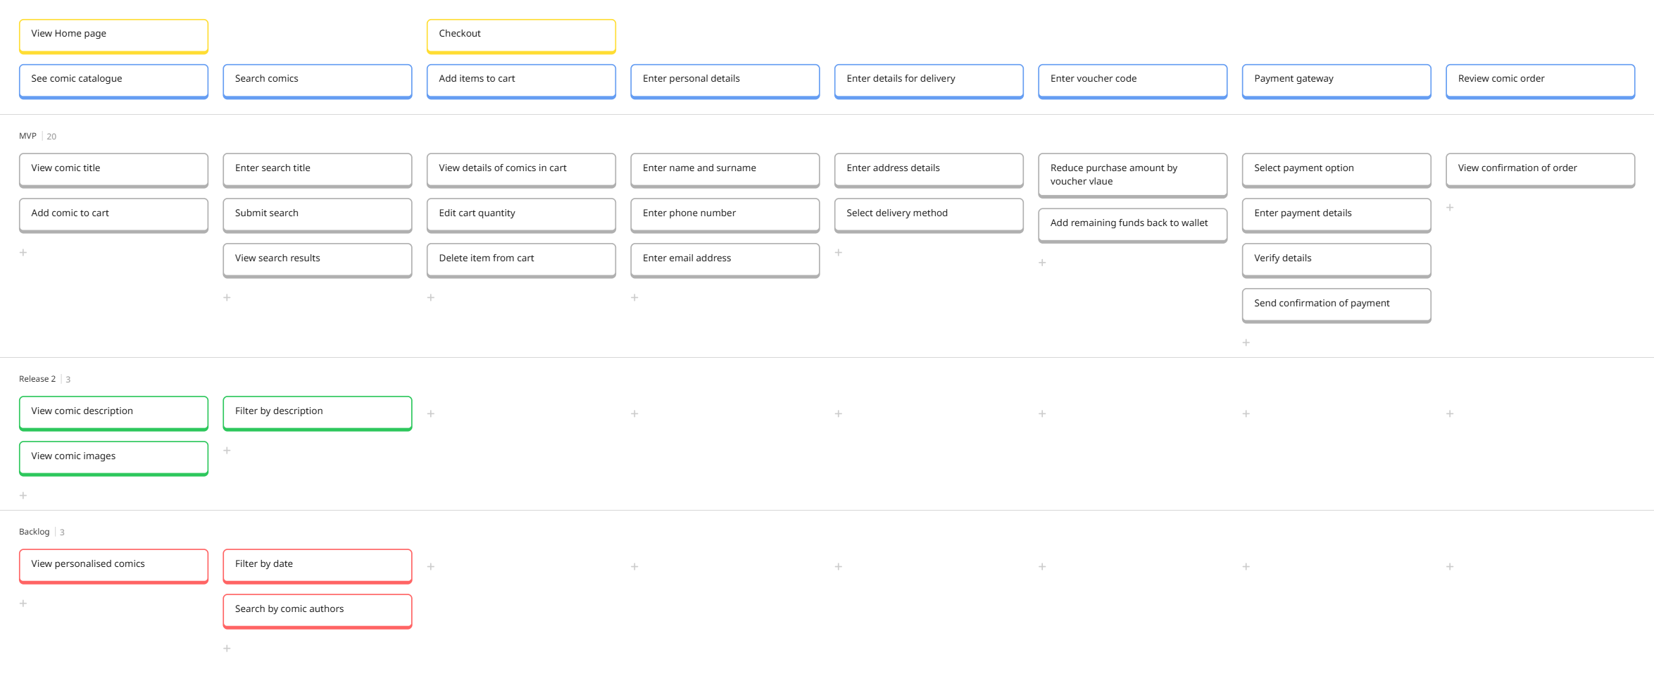

Check out miro here

